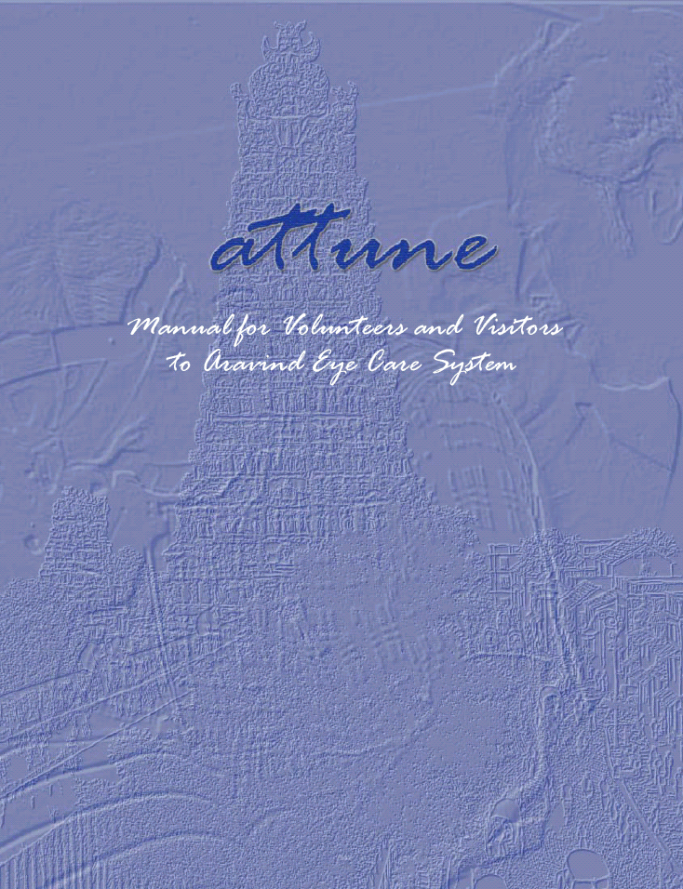

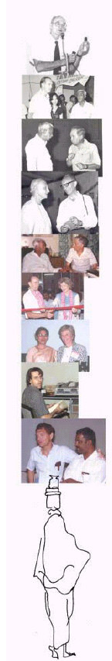
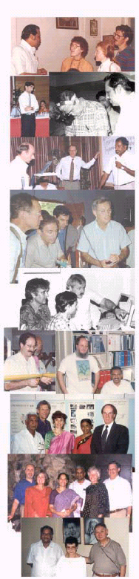
Aravind’s relationship with people goes a long way. True to the Indian tradition , anyone entering the portals of Aravind is warmly received, and soon becomes a part of the Aravind Family.

Aravind has always believed in the capacity of people and the continual need to upgrade its own strengths. The constant flow of visitors and volunteers over the years has played a major role in Aravind’s growth.

The number of visitors and volunteers to Aravind has steadily increased with the growth of the Institution. From the modern Aravind Guesthouse “Harmony” to separate staff that coordinates the volunteer/training activities, Aravind has paid careful attention to ensure that visitors’ experiences are memorable ones. This manual is intended to provide an overview of Aravind Eye Care System and Madurai before the visitor or volunteer actually arrives in Madurai, India

This manual is in three sections:

- The first section provides an overview of the Aravind Institution, the senior leadership team, the facilities in the Organization and the organization culture that Aravind upholds.

- The next section provides general information, such as
formalities to be completed to get here, communication and
transport facilities, the appropriate clothing, about the
people, and the lifestyle here.

- The third section provides information about the places to visit in and around Madurai.


WELCOME TO ARAVIND

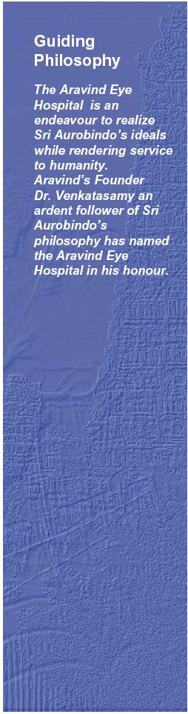
Sri Aurobindo and the Mother

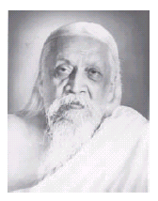
Sri Aurobindo:
Sri Aurobindo was born in Calcutta on August 15,1872. He is one of the most revered spiritual leaders of the twentieth century, in addition to being a great patriot, poet, philosopher and mystic who lived in service to God and humanity. When he started his life in Pondicherry as Sadhak four or five disciples joined him. Later with more and more disciples following his spiritual path, the number became so large that a community had to be formed for the maintenance and collective guidance of those who had left everything behind for the sake of a higher life. This was the foundation of the Sri Aurobindo Ashram.

Sri Aurobindo’s symbol :
The descending triangle represents Sat-Chit-Ananda (the pure consciousness of the divine) The ascending triangle represents the aspiring answer from matter under the form of life, light and love. The junction of both, the central square: is the perfect manifestation having at its centre the Avatar of the Supreme-the lotus. The water inside the square represents the multiplicity, the creation.

The Mother:
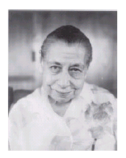
The Mother was born in Paris (1878 –1973), and earned a name as an accomplished painter, talented musician and writer. At the age of thirty-six, the Mother came to Pondicherry and met Sri Aurobindo. At once she recognized him as the master, who, for many years had inwardly been guiding her spiritual development. From1920, she resumed her collaboration with Sri Aurobindo and remained in India for the rest of her life. In November 1926, Sri Aurobindo entrusted the full material and spiritual charge of the Sri Aurobindo Ashram to the Mother. Among one of the achievements of the mother is the creation of the Sri Aurbindo International Centre of Education and the initiation of Auroville

Mother’s symbol :
The central circle represents the Divine consciousness. The four petals represent the four powers of the mother. The twelve petals represent the twelve powers of the Mother manifested for Her work.

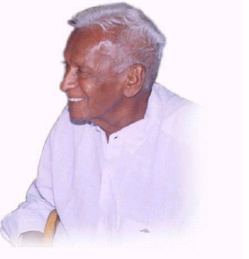
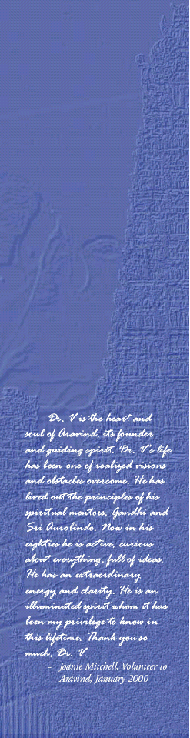
Dr. G. Venkataswamy (Dr. V):
Dr. G. Venkataswamy, the Founder and Chairman of Aravind Eye Hospitals, was born on October 1,1918 in Vadamalapuram, a small village 80 kms from Madurai. He received his medical degree from Stanley Medical College in Chennai in 1944. Thereafter, he joined the Indian Army Medical Corps, but had to retire in 1948 after developing severe rheumatoid arthritis, a disease that left his fingers crippled and changed the course of his life. Despite his condition, he returned to medical school and earned his diploma and masters degree in ophthalmology. With hard work and determination, Dr. V. trained himself to hold a scalpel and perform cataract surgery. In time, he personally performed over one hundred thousand successful eye surgeries. During his service, Dr. V pioneered state-level programs in 1961 to address blindness, by establishing mobile eye camps. Villagers living in distant villages were reached by these mobile eye camps, where their eyes were tested, diagnosed, and treated. In 1965, Dr. V. visited the United States for the first time, to attend a conference on the rehabilitation of the blind. It was at this conference in New York that Dr. V. struck a life-long friendship with Sir John Wilson, the founder of the Royal Commonwealth Society for the Blind (now known as Sight Savers International), an organization that was supporting eye camps in India. Dr. V and Sir John Wilson met the then Prime Minister of India, Mrs. Indira Gandhi, to ask for support for a national organization to control blindness. Dr. V. in the meanwhile had also accompanied the then Chief Minister of Tamil Nadu, Mr. Karunanidhi for his eye treatment, and the latter supported the government sponsored eye camps all over Tamil Nadu spearheaded by Dr. V. Thus, even before Dr. V. retired, he was overseeing the growing network of eye camps all over Tamil Nadu and had developed a network of friends and well wishers across India, who empathized with his passion for providing good quality affordable eye care.

In 1976, after mandatory retirement from government service at the age of 58, he formed the GOVEL Trust under which the Aravind Eye Hospital was founded. Guided by a philosophy that taught the spirituality of service, driven by compassion far beyond the ordinary, and backed by the support and assistance of those who believed in his vision, Dr.V set in motion a 27-year-old- and still continuing crusade against blindness. His work and its remarkable results have gained international recognition. He is the recipient of many awards; among them are the Helen Keller International Award, the International Agency for Prevention of Blindness Award and the International Blindness Prevention Award by the American Academy of Ophthalmology.

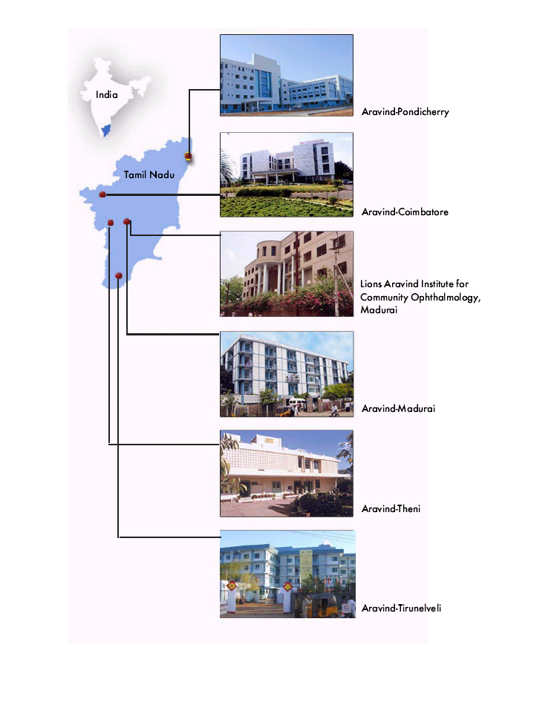

The Aravind Eye Care System

THE Aravind Eye Care System

In 1976, the GOVEL Trust started a modest 11 bed hospital, and called it the Aravind Eye Hospital, named after Sri Aurobindo, Dr.V’s spiritual master. This hospital was run with a mission of serving the poor blind people, and was located in the house of
Dr. V’s brother, at Madurai. In this hospital, five beds were reserved for patients who could pay for the treatment and six were reserved for those who could not, and who were offered free treatment.

By 2003, the humble 11 bed hospital with 3 doctors, had grown into The Aravind Eye Care System, one of the most productive eye care systems in the world, with 3600 beds and 240 doctors(including those in the satellite hospitals.) The Aravind Eye Care System is not merely a chain of hospitals, but is an eye care system consisting of a unit for manufacturing synthetic lenses, sutures, and some pharmaceuticals used in eye care; an institute for training; an institute for research; an international eye bank; a post graduate institute of ophthalmology awarding M.S. degrees and offering fellowship programmes; and a centre for community outreach programs.

An organizational culture with a strong work ethic and a commitment to service has been institutionalized. Aravind is committed to providing high-quality, compassionate eye care to all those in need. Aravind’s innovative eye care delivery system has achieved international recognition and attracts consultants and students of ophthalmology from around the world. Aravind is at present serving a population of 15 million. The main aim and motive of Aravind Eye Hospital is to eliminate needless blindness through the provision of high quality, high volume service delivery. Over the years, Aravind has demonstrated its commitment to innovation and on-going development. Free eye screening camps are conducted everyday in villages throughout Southern India and also in Maldives.

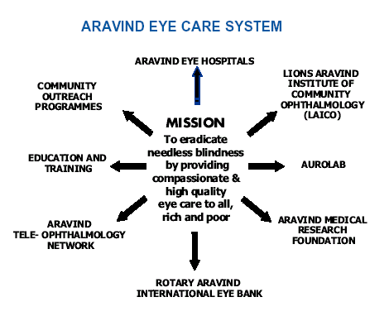
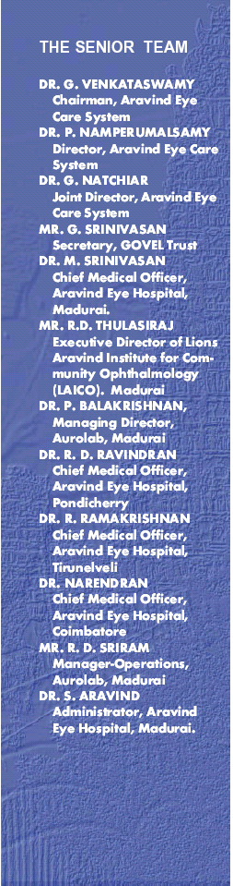
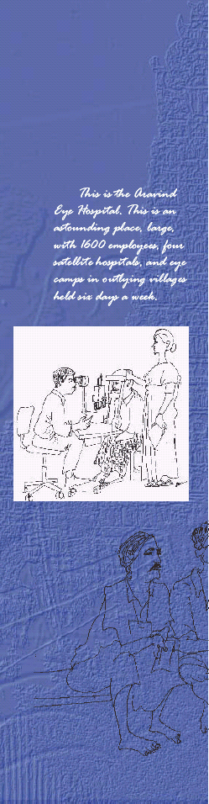
Sub-specialty Clinics  Retina and Vitreous  Cataract and General Ophthalmology  Neuro-Ophthalmology  Cornea  Paediatric Ophthalmology & Strabismus  Glaucoma  Uvea  Orbit and Oculoplasty  Support Facilities  Ocular microbiology laboratory  Ophthalmic research laboratory  Biochemistry  Radiology  Photography  Instruments maintenance laboratory  Patient counseling services | Community Outreach  Aravind reaches out to the unreached through community outreach programmes like Free Eye Camps, Village Volunteer Programme, School Eye Health Screening and comprehensive  eye care services.  Eye Bank  The Rotary Aravind International Eye Bank established in 1998, marks a step forward in providing a sustainable solution to the problem of corneal blindness. It is one of the four eye banks in the country affiliated with the International Federation of Eye Banks.

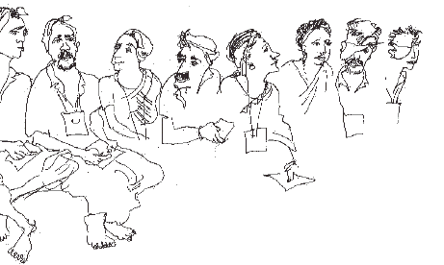



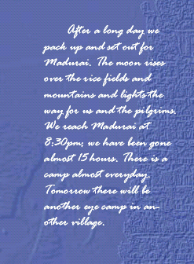

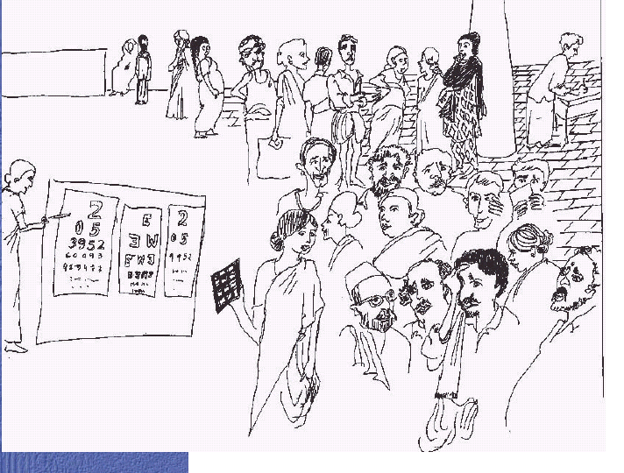

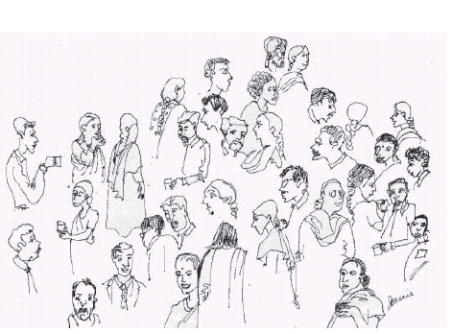
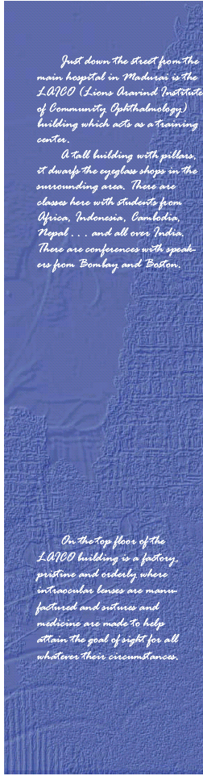

Lions Aravind Institute of Community Ophthalmology  LAICO is Asia’s first international training institute for blindness control programmes. It works towards a mission of contributing to the prevention and control of global blindness through teaching, training, research and consultancy.  LAICO offers the following courses  · Health and Hospital Management Course  · Postgraduate Diploma in Hospital Management  · Postgraduate Diploma in Health Management  Task oriented training courses  · Instruments Maintenance  · Community Outreach for Eye Care  · Patient Counselling  · General Orientation to Hospital Management  LAICO also co-ordinates several clinical courses, that are offered by Aravind to increase the ophthalmic human resources in the country and to provide continuing skills development. At present, LAICO works with over 169 eye hospitals in India, Nepal, Bangladesh, and in several countries in Africa and South East Asia. | Aurolab  Aurolab is an independent non-profit charitable trust established in 1991. It was founded with an aim to manufacture and provide even the poor with the best technology. Today Aurolab manufactures intraocular lenses, ophthalmic suture needles, low vision aids, ophthalmic pharmaceuticals, and spectacle lenses. Some of the products are exported to over 120 countries and have ISO 9002 certification. Aurolab lenses received the prestigious CE mark certification from the Danish Certifying Agency, DGM. This product certification is mandatory for the sale of the product in the European Union (EU) countries. Aurolab is the first Indian manufacturer to receive this product quality certification for intraocular lenses. In order to meet the emerging demand from customers, the lens division is planning to expand its capacity and product range by including foldable lenses

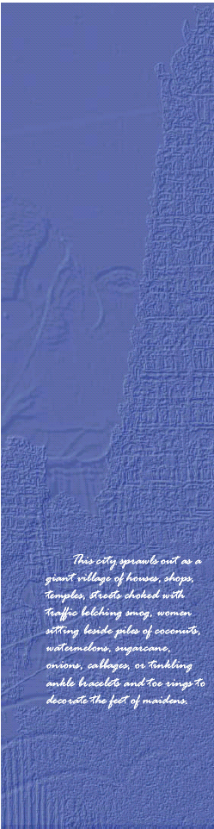
Role of Volunteers/Visitors
Volunteers contribute to the development of Aravind in innumerable ways. Their assignments ranging from a few weeks to a couple of years, have provided inputs on quality, improvement of human resources, consultancy, information technology, information
management and a wide range of clinical fields. These guests have been able to work in a focused manner, bringing a new or fresh perspective. When a volunteer prepares to arrive at Aravind it is essential to bear in mind a few of the formalities to be completed.

Preparation for Living and Working in India

Language
At Aravind most of the staff understand English though accents may vary and hence it might be necessary to talk slowly. However, an effort to learn the phrases for greetings and a few basic courtesies like, thank you – ‘Nandri’, welcome-‘Vanakam’, will always be
appreciated. For long-term visitors, Aravind can arrange language tutoring. ‘Functional Tamil’ a booklet of common everyday terms (English to Tamil), is available at the ‘Stores Department’ in
the hospital.

Culture

Make a sincere attempt to understand differences in the working culture.

The following are appropriate practices:

· Listen politely and carefully.
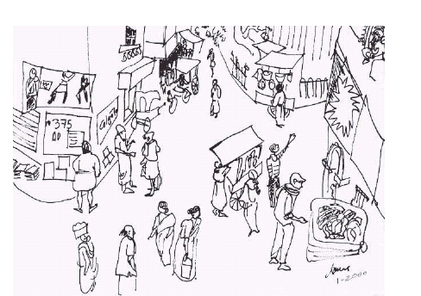
· Offer suggestions and make factual points tactfully.
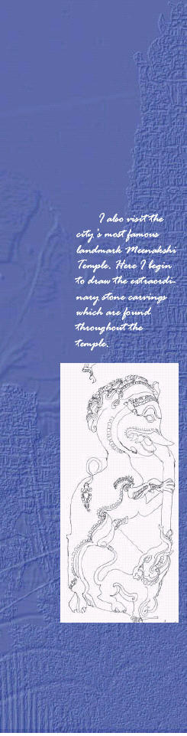
· Avoid criticism of local customs or traditions.
· Behave gently and be aware of locally offensive body language.
· Use only your right hand to give or receive anything.
· Avoid aggressive behavior.
· Be a patient guest; the pace may not be as fast as that to which you
are accustomed. The formality of sitting at length in conversation
is a time-honored custom.
· Be an appreciative guest; many hosts extend a warm generous
welcome. Words of appreciation are always appropriate.
· Don’t shake hands unless a hand is offered. If in doubt say “Namaste” with both hands folded, especially when greeting
women.
Handshakes may be longer and could involve both hands at times.
· It is recommended/required to remove the shoes before entering
into a temple or someone’s house.
· Indians assume that Westerners dislike hot and spicy food, so if
you prefer hot and spicy food do tell them.
· If Indians insist on paying for things, don’t force the issue.
· Observe social protocols in meetings - for example, don’t force
junior people to speak in front of the seniors.
· The approach to time-management in India is more relaxed than
abroad, so don’t be surprised if people turn up late for meetings
or just cancel it at the last minute.
· It’s a friendly and common gesture for people of the same sex
to hold hands.
If this is your first exposure to India you should come with a completely open mind and not make evaluative judgments,
nor jump to conclusions, when differences arise.

Working Hours
LAICO and Aravind Eye Hospital work six days a week Monday through Saturday. The working hours of the hospital are generally 7:00 am to 5:30 pm and at LAICO the official hours are from
9:00 am to 6:00 pm. Smoking, consumption of alcohol, and chewing
gum are not permitted within any of the Aravind premises.

Pre-arrival Formalities
Visa
A Visa is necessary for you to travel to India. Please contact your local Indian embassy or consulate for the proper forms and information. Having spare passport sized photographs with you will also be useful. Depending on the length of your stay it may be necessary for a Residential Permit from the police department in Madurai on arrival, which could also be done with the help of Mr.Jeyachandran, in the hospital. It is advisable for any assignee to carry additional copies of visa/passport/residential permit other than the copy for oneself.
Insurance
It is a wise idea to obtain a travel insurance policy to cover theft, loss and medical problem before leaving for India. There are a wide variety of policies on which your travel agent will have recommendations. Be sure to check the small print that covers things like an emergency flight home with a medical escort and the ambulance costs. Keep a copy of this policy separate from the original.

Clothing

Since Madurai is warm even in December and January, you really do not need any warm clothes. However, if you are planning to travel to North India during winter months or if you plan to
visit any of the regional hill stations, it is advisable to bring adequate warm clothes, as it could be cold.
· Women will need long skirts and probably loose fitting tops (not
sleeveless). Tight leggings/jeans and skimpy tops would be
inappropriate.
· Men mostly wear button-down shirts (short sleeve) and loose
trousers (not jeans or shorts) to work.
· Sandals or other loose shoes are appropriate footwear. Many men
wear socks for fear of foot problems. Flip-flops are useful and can
be purchased locally at a cheap rate.
· Cotton clothes are more suitable for this climate.

Health and hygiene Tips

· Before leaving your own country you should visit your doctor to
receive information on the precautions and vaccinations needed
for India.
· It is advisable to use insect repellent on exposed areas particularly
at dawn and dusk.
· Contact lens wearers may find it difficult especially in the dusty
environment of rural areas and hence it’s advisable to wear
sunglasses.
· The sun is scorching from 10:00 am until about 4:00 pm. Sun
protection body lotion is important and should be brought with
you.
· For people with asthma, extra precaution will have to be taken,
as the level of dust on the street is higher than one might be used
to.
· Medicines are available at a low cost at all the drug stores in
Madurai, so carry only that which is necessary for your daily
routine. Keep lozenges with you. You may need them.
·. Toilet articles (e.g. deodorant, shampoo, and toothpaste) are easily
available, so don’t carry more than you need.

Arrival at Madurai

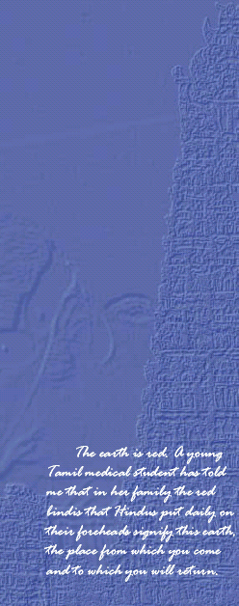
Madurai is situated 300 miles South of Chennai. It can be reached by direct flights from Chennai and Bombay (Mumbai).
Travel Information:
Air
There are daily flights to Madurai from Chennai, Bangalore,Tiruchi & Coimbatore. The Madurai Domestic Airport is 10 kms away from Madurai City.
Flight Details [Time Schedule & Fares] ---to be regularly updated
Rail
Madurai is an important railway junction of the Southern Railway and is directly connected to Chennai and Tirunelveli. Madurai is on the Madurai-Tiruchirappalli-Dindigul-Quilon line. The Vaigai Express, which is a super-fast day train between Chennai Egmore and Madurai takes 7 hours for the 495kms.
Time Schedule (Madurai Railway Station)---update
Railway Fares and Destinations
Road
There are excellent roads connecting Madurai to all parts of South India. Madurai City has 5 Major Bus Stands.
Click here to view the Bus timings. ----update
If you are entering India
· through Delhi, then the best route will be Delhi-Chennai- Madurai.
· through Mumbai, then you can reach Madurai by an Indian
Airlines flight, which has a stopover at Chennai, Mumbai-Chennai-
Madurai or a direct flight, Mumbai-Madurai.
· through Chennai, take a flight from Chennai to Madurai (please
check timings with your Travel Agent).
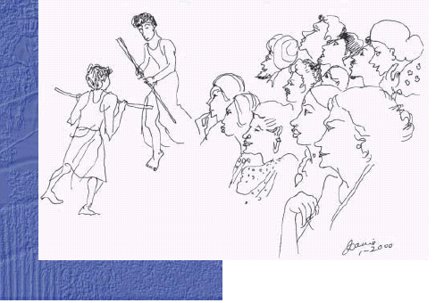
From the experience of the previous visitors, it is felt that entering through Mumbai or Delhi Airport is preferred in terms of immigration formalities and customs. Please make sure that you
have reservations all the way up to Madurai made well in advance.
· You’ll be asked to complete immigration and customs forms
on the flight.
· Do not lose the small form that the immigration officer gives you
back at customs, as you’ll need to hand this over as you leave the
arrivals hall.
· Immigration can take some time, as will changing money at the
airport.
· Baggage handling is usually reasonably fast.
· You will need to change money at the airport. It’s advisable to do
this in the arrival hall immediately after collecting your baggage at
the International Airport. Request for some small notes e.g.Rs. 10
in change, because you’ll need them for tips. Keep all exchange receipts, as you may need them on departure.
· You can use prepaid taxi or courtesy buses for transport from the
International to domestic terminals at Mumbai and Delhi. In
Mumbai and Delhi, there are two terminals at the domestic airport,
one for the Indian Airlines, and the other for all private airlines.
Make sure you go to the right terminal.
· In Chennai you can walk from the international terminal to the
only domestic terminal.
Departure
· To change all rupees back to your local currency (i.e. sterling or
US dollars), you’ll need the official exchange receipts for
conversion to rupees covering more than the amount you’re trying
to change back to your local currency, so don’t pack all receipts in
the suitcase you’ve just checked in! You are allowed to take
Rs.1000 out of the country, but changing back to your local
currency is strongly advised.
· When you check-in you will be given an immigration form to
complete, do this before going through customs.
· At Mumbai there are shops and cafes in the departure area, and it
is more pleasant to wait there rather than at the check-in desks.
You can pay in dollars, sterling or rupees. Prices are quite xpensive.

Some air travel tips
· Planes are sometimes double-booked and confirmation of booking
and flight time is important. You can usually do this through the
travel desk at the hotel for a small fee or at Aravind Hospitals
before you leave. Confirming internal connections for onward
international flights is not necessary.
· Retain the baggage tags that are given when you check-in, as
security may require you to hand this over when you leave the
destination airport.

· On domestic flights you may have to identify your baggage after
passing through security. (This does not happen on all flights, but it is worth checking or your luggage might not be loaded onto the plane).

Transportation
· Roads in most areas can be rough. Self-driving or night travel by
road is not recommended.
· Right hand driving is practiced here. (In other words, drive on
the left side of the road)
· Buses, autorickshaws, taxis etc. are available and they aid in
traveling from one place to another.

Autorickshaws
Autorickshaws can be found at specified auto stands or you could flag one down on the road, like you would for a taxi back home. Get in only after fixing the price. Autorickshaws in Madurai often refrain from using meters and hence it is necessary that you agree on a price. The approximate price for a few places is listed at the guesthouse for your convenience.

Buses
Buses are frequent in Tamil Nadu and are preferred for long distances. The local buses for travel within the city are very crowded. It is much more comfortable to use an air-conditioned car/taxi with a driver who will wait for you at a charge of about Rs.40 per hour. It is advisable to write down the address you’re going to, as the driver may require it for directions.

Trains
At the station you could buy a train ticket by going round to the side entrance and going straight in rather that queuing up behind everyone else. This is a special provision made for tourists. Trains need to be booked in advance. This should be done at the start of

your travel, for the return journey. Though there are different classes like II and I, and A/C, it is advisable to travel by the air-conditioned class .
The hospital will be able to assist you in booking a ticket. Water and
food should be taken along while traveling, as it is better not to eat the food, which is available at the platforms or in the trains. Bananas, biscuits etc. may be bought on station platforms.

Communication

Postal
The post and post-related services like courier, fax, telegram are generally excellent. There is a post office near the Gandhi Museum (walking distance from the guesthouse), called the Gandhi Nagar Post Office.

Telephones
The public phone booths for making interstate and international calls (which are indicated by STD and ISD) are located on many streets near the hospital and guesthouse. In addition there is an STD and ISD booth at the hospital.

E-mail
This may be your main form of communication. Cyber world is a
4-block walk from the guesthouse and they offer Internet access at nominal charges. There are quite a few cyber cafés within walking distance of Aravind Eye Hospital..

Exchanging Money
You can use your credit card or pay in travelers’ cheques in the big textile shops in town. You can go to government approved exchange offices or hotels to exchange money. You may contact the hospital cashier for help to exchange foreign currency.

Entertainment


Movies
Tamil films are very popular in Tamil Nadu and a number of theatres are located in Madurai. Some theatres show English films also. Most of the theatres are air-conditioned. Check the local paper (The Hindu is provided to the guesthouse everyday) for details.

Festivals
Madurai is a city which celebrates fairs and festivals in a very grand manner. People enjoy festivals with their families The festivals that are generally celebrated are the Avanimoolam festival in January, Float festival in January, Chithrai festival in April, Jalikattu in January and many others.
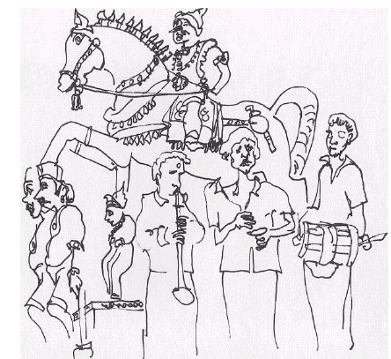

Shopping
Shopping here is a whole new experience. Some shops have the system of receipt – pay - collect. Shop contents are different and
you may not be able to get what you have at home Smaller shops are often grouped together in the same area selling the same items.

Shopping tips…
· Books and cotton clothes are cheap.
·Local handicraft is beautiful, and can be found in several shops
· Shopkeepers will hassle you to enter their shops and rickshaw
drivers may insist on taking you to shops that pay them a commission. To avoid this, check with people at the hospital or guesthouse and ask the richshaw driver to take you to a specific place

·You could bargain if it is not a fixed price
· Markets may be overwhelming with noise, crowds, and narrow
streets –especially for women.
·Meat is not evident. Fruit and vegetables are impressive in quality
and price (e.g.12 small bananas for 10 rupees).
· Places for shopping like Pandyan Hotel (pay ¼ of sticker price),???
Madurai Gallery for carpets, jewelers, wall hangings, silver ware,
brass ware, sandal wood, marble, silk & wool materials;
Hajeemoosa for shirts, trousers and dress materials.
· The best-known Indian outfit is the Sari. Although a majority of Indian women wear this traditional costume, many Indian men wear quite conventional western clothing.
Well- experienced tailors throughout the city will help you to get loose fitting dresses stitched.
· Churidars or Salwar Kameez are also elegant and comfortable
to wear. Most Indian girls and younger women prefer wearing
them.
· Next to the famous Meenakshi Temple is a famous spot -‘the
Puthu Mandapam tailors’. This is a delight for most visitors. You
could select the material and then you can choose from a dozen tailors or so and have the outfit tailored to your design and measurement. Rather than carrying a lot of clothes in your luggage it is sufficient to bring the bare minimum, as this is a cheaper option. When ready the clothing will be delivered to the guesthouse at no extra cost.

Reading
· A wide selection of books are available at the Aravind Guesthouse
· The library facilities are available both at Aravind Eye Hospital
and LAICO

Guide Books
· Lonely Planer Guide – South India
· The Internet version of the Lonely Planet contains excellent
“post cards” (i.e.hints and tips from travelers), with particularly
good advice for women travelers.
· Culture Shock – India
· Working with an Indian Partner
· Cross – cultural effectiveness.

Fiction/Travel
· “Calcutta: City of Joy” - LaPierre
· “May You Be the Mother of A Hundred Sons” - Jung
· “No Full Stops in India” - Tully
· “India: A Million Mutinies Now” - V.S. Naipaul
· “Chasing the Monsoon” - Frater
· “Travels with my Elephant” - Mike Shand
· “Green Well Years” - Manohar Devadoss

Videos
· The Sandus –Part I and III
· Oxfam – “Silver Shackles”
· Norton – “The non-profit sector in India”

Food

· Rice is the staple food of South India. Indian breads (‘chapattis’
and ‘purees’) are always delicious. Tamil Nadu is famous for its
‘idli’ (steamed rice cakes) and ‘dosas’ (pancakes).
· Aravind provides food for visitors, which is prepared
in the guesthouse. Soft drinks, coconut water (tender coconut)
and mineral water are available everywhere.
· Outside the guesthouse it’s best to remain vegetarian, as the
freshness of the meat and fish cannot be guaranteed. Many
restaurants offer a wide choice in vegetarian dishes. Alcohol will
not be served in most places.
· On some occasions you will be expected to eat with your hands.
Use only your right hand to eat. Your right hand is considered to
be contaminated once it has touched your mouth, hence refrain
from using it to serve food from dishes on the table and use your left hand for this. If you have food on your plate (or banana leaf ) it should be touched only with your right hand.
· Jung – “May You be the Mother
of a Hundred Sons”
· Tully – “No Full Stops in India”
· V.S. Naipaul – “India: A Million
Mutinies Now”
· Frater – “Chasing the Monsoon”
· Mike Shand – “Travels with my
Elephant”
· Manohar Devadoss – “Green Well
Years”
Videos
· The Sandus –Part I and III
· Oxfam – “Silver Shackles”
· Norton – “The non-profit sector
in India”
· Expect to find mainly Indian and
“Indian” Chinese food, although
western food is becoming more
widely available.
· Spicy food is traditionally served
for breakfast, for example idli or
dosa with spicy sauce. The
Aravind guesthouse provides a
western style breakfast with eggs,
toast, porridge, fruit and coffee/
tea.
· The sequence of eating food is
often different from what you
may be accustomed to back
home. A sweet is sometimes
taken first, followed by hot curry
and bread (roti, nan, paratha etc.),
cooler curry (called gravy) and

rice with curd (beware of the curd which may not be pasteurized). It is best to ask/watch what others are doing if you feel unsure. Milk products in general could cause stomach disorders.
· A Thali or the South Indian meal is a complete meal including
dessert, usually delicious and very nutritious.
· In rural areas you are likely to be served, and food will continue to
be served on your plate or banana leaf until you say stop or ‘bus’
(Hindi), or ‘podhum’ (Tamil) which means enough or fold your
banana leaf in half.
· Tender coconut milk is good and is used as a cool drink consumed
directly from the coconut shell. Coconut milk is also used in
cooking.
· You may try Indian beer. Among the different brands of Indian
beer, Kingfisher is popular.
· Road side coffee and tea is not safe to drink and is likely to cause
infection.

Places to eat and drink

THE SUPREME HOTEL has a roof-top restaurant that provides a good view of the temple. It has only a vegetarian menu. The Apollo 99’ nightclub downstairs will transport you to another planet!
THE PARK PLAZA HOTEL – has a roof-top restaurant, and offers a non-vegetarian menu as well.
KONAR MESS near Simmakal (meaning the Lion stone)-serves a wicked mutton dosa (a local delicacy) for those with an iron constitution.
RUBY’S RESTAURANT (just off Town Hall Road – a short walk from “Konar Mess”) – serves nice cool beer.

Other nearby less expensive restaurants include Amutham and Mahal.
KALPATARU in K.K. Nagar is a cozy restaurant with good food
THE NEW RAJESWARI HOTEL – within walking distance of the guesthouse, also has a roof-top restaurant.
THE MEENAKSHI BHAVAN – near the Anna bus stand offers a wide range of traditional South Indian food.
THE POONGA ARYABHAVAN – opposite the Gandhi Museum, offers a wide range of traditional South Indian food. It has pleasant outdoor seating and live music on Saturday nights.
HOT BREADS – near KK Nagar Arch, offers baked foods, soups and a variety of more western style foods.
ABBI’S CAFE and UFO are both very close to the hospital and LAICO with a relaxed western coffee shop feel and also serve light meals.

Leisure

Bicycle rides
If you would like to get away from the ‘hustle and bustle’ of the city, bicycles are available at the guesthouse. You can pedal your way to the countryside with its lush green rice fields. All this is just a short distance from the guest, and is a nice way to explore the immediate surroundings. You can ride to the Veraganoor Dam and along the river or out to the Elephant Rock and Thirumohur temple.
It is advisable to check out the routes in advance and be careful while riding on the busy main roads of Madurai. There are many picturesque rice paddies, coconut groves, and quaint friendly rural villages on the outskirts of the city.

Swimming
The Hotel Sangam has a small swimming pool, and sun beds. They charge Rs.100 for a day. After ‘a quick dip’ you could have a massage in the beauty parlor, which offers a wide range of their treats. The Taj Garden Retreat Hotel is situated out of town, and will cost you Rs.80 – 90 by autorickshaw to get there. It provides a spectacular view over the whole of Madurai in a very peaceful setting. The hotel has a swimming pool, which costs Rs.300 for the day and includes towels, changing facilities and showers.

Yoga
For early risers there are Yoga classes held at 6:00 am each morning on the rooftop of the MAVMM School near the Meenakshi Bhavan, on the way to the Gandhi Museum. Classes are held Monday through Saturday, for an hour and a half and cost Rs.150 per month. Alternatively, you could bang a drum on the Japanese Buddhist Temple roof near the Gandhi Museum. This ritual takes place every evening around 5:30 pm and is very therapeutic.

Churches

For Christian visitors there are many churches in Madurai, including 4 masses every Sunday at the beautiful and historic St. Mary’s Cathedral (conducted in Tamil). Sunday services are held at the American college chapel (conducted in English) and regular 7:30
am/6:00 pm communion mass at the pretty church of the Divine Patience in the Railway Colony (conducted in English). There are various other churches, such as the large Lutheran Church near the railway station and the Pentecostal church (conducted in Tamil and some times translated to English) at KK Nagar.

Climate
South India is generally hot and humid for most of the year. Daytime temperature ranges from 25 to 45 degrees centigrade, during winter and summer. The rainy season strikes in May/June and a smaller monsoon once again in November/December.
Basically Tamil Nadu is a three season year-the very hot, the wet and the ‘not so hot’. The best time to visit is during the months of July to February. April and May are hot months with a maximum temperature of nearly 45C.

Health & Hygiene
· Drink lots of bottled water, which could also be carried with you. If
bottled water is not available request well-boiled water. Use bottled or boiled water for cleaning your teeth. The guesthouse supplies purified water.
· Your travel health depends on your pre-departure preparations,
your daily health care while traveling, and how you handle medical problems if any occur. Just as you take care and use certain safety precautions at home, you must be aware of dangers in situations here also. If your health is affected in any way, medical facilities are available at Aravind.

General Information

India with its traditional and diversified culture stands unique in the south of Asia and attracts many visitors from abroad. Nearly 19 languages are spoken in India. Though Hinduism is the main religion, others like Buddhism, Sikhism, Jainism, Christianity, Islam
and Judaism are also practiced. India has the second largest population in the world, which recently crossed the 1 billion mark. There are numerous places of interest in India. India saturates the senses, from the tropical backwaters to the towering Himalayan
peaks.

Tamil Nadu, situated in Southern India is the home of Dravidian art and culture, characterized by the amazingly ornate temples with their soaring towers known as gopurams. Chennai, (Madras)
‘The Gateway to South’, is the state capital.

About Madurai:

One of South India's well-known temple towns, Madurai is synonymous with the celebrated Meenakshi Temple. Situated on the banks of river Vaigai, Madurai has a rich cultural heritage passed on from the great Tamil era more than 2500 years ago. Madurai was an important cultural and commercial centre even as early as 550 AD. Its origin and name emerge from the myths of a lovely legend. In a forest near the lotus pond, Indra, King of Gods, worshipped Lord Siva as a Swayambu Lingam. At this hallowed spot the Pandiyan monarch, Kulasekhra, built a great temple and by clearing the forest, created a lotus-shaped city around the temple. On the day the city was to be named, as Lord Shiva blessed the land and its people, divine nectar (Madhu) was showered on the city from his matted locks. This city was henceforth known as Madhurapuri. Madhurapuri grew and prospered to become the capital of the Pandiyan Kingdom. It is referred to in the Ramayana and in Kautila’s Arthasashtra. Foreign travelers of ancient times also had heard of it. Madurai lies on the banks of the river Vaigai, andis famous today for the Meenakshi temple and the sweet smelling jasmine flowers. The temple and the old city are on the southern bank, while modern Madurai with its textile mills; engineering colleges and large university sprawl around.

General Information:

Area | 22 Sq. Kms ( 8.56 Sq. Miles)
Population | 10.9 lakhs(As per 1991 Census)
Altitude  Latitude & Longitude | 101 meters (330 ft) above sea level  Latitude : 9.58 N Longitude : 78.10 E (Click Here)
Clothing | Tropical
Season | Throughout the year
Languages Spoken | Tamil, English, Sourashtra
Festivals | Madurai Meenakshi temple has festivals in all twelve Tamil months.  Some of the popular festivals are  Chithirai Festival (April - May )  Avanimool Festival (Sep - Oct )  Navarathri Festival  Float Festival (January- February )
STD Code  (Direct Dialing Code) | 0452
Shopping | Shopping Areas in Madurai city  (Books, Handlooms, Fabrics & Sarees, Departmental Stores)

SHOPPING: FAMOUS FOR ????

Places of Interest in and around Madurai

In Madurai
In Madurai there are interesting places like the Meenakshi Amman Temple, Gandhi Museum, and other places nearby to be visited at weekends or evenings. Local travel agents can organize short trips, for example to Rameshwaram or Alagarkoil Temple. There are also periodic special events and festivals, which are announced by the Tamil Nadu Tourist Office or local newspapers, for example Jallikattu – Alanganallur, Pongal and classical dance or music concerts.

Meenakshi Amman Temple
The main attraction of Madurai is the Meenakshi Amman Temple, which is situated in the heart of the old town. It is a fine example of Dravidian architecture with gopurams covered from top to bottom with breathless profusion of multi-coloured images of gods, goddesses, animals and mythical figures. The enormous temple complex is dedicated to Lord Shiva, (known here as Sundareshvara) and his consort Parvati or Meenakshi. The original temple was built by Kulasekara Pandya, but the entire credit for making the temple as splendid as it is today goes to the Nayak Dynasty. The Nayaks ruled Madurai from the 16th to the 18th century and left a majestic imprint of their rule in the Meenakshi - Sundareswarar Temple.
The temple complex is within a high-walled enclosure, at the core of which are the two sanctums for Meenakshi and Sundareshwara, surrounded by a number of smaller shrines and grand pillared halls. Especially impressive are the 12 gopurams. Their soaring towers rise from a solid granite base, and are covered with stucco figures of deities, and other mythical (animals and monsters) figures painted in vivid colours.
Temple Towers
There are 12 temple towers(Gopuras). The outer towers are the landmarks of Madurai. They are:
- East Tower (Nine storeys high). Height 161'3". This Gopuram has 1011 sudhai figures.
- . South Tower (Nine storeys high). Height 170'6". This tower has 1511 sudhai figures.
3. West Tower (Nine storeys high). Height 163'3". This Tower has 1124 sudhai figures.
4. North Tower (Nine storeys high). Height 160'6". This Tower has lesser figures of sudhai than other outer towers.
Gopura:
Pyramidal gates(gopuras) rise to a height of more than 50m. These towering gateways indicate the entrance to the temple complex at the four cardinal points, while lesser gopuras lead to the sanctums of the main dieties.
Stucco Work:
The figures of deities on the tower are repaired, painted and ritually consecrated every 12 years.
Ashta Shakthi Mandapam
A visitor who enters the temple through the eastern gateway, first enters this Mandapam(Hall). It was built by Thirumalai Nayakar's wives Rudrapathi Ammal and Tholimamai. In this hall food was (once distributed) served to the devotees who came from far off places. Next to this hall is the Meenakshi Nayaka Mandapa, a spacious columned hall used for shops and stores. This hall has a votive lamp-holder with 1,008 lamps, which are lit on festive occasions and present a spectacular sight. The sculptures on the pillars here relate some of Lord Shiva's thiruvilayadals (miracles) and also the story of Meenakshi's birth and her life as the princess of Madurai.
The story described on the stones is as follows:
Malayadwaja Pandya, a king of Madurai, was childless for a long time. He performed a number of yagnas (sacrifices made before a sacred fire) because he wanted an heir to his throne. On one such occasion, a three-year-old girl came out of the fire and Malayadwaja adopted her. But the girl had three breasts and this worried Malayadwaja. However, a divine voice assured him that the third breast would disappear as soon as she met her consort. The girl grew into a brave and beautiful princess. She won many battles, and eventually lost her heart to Lord Shiva, when she met him on the battle-field in Kailas. As soon as she saw him, her third breast disappeared and she recognized her divine consort, for the princess was none other than Shiva's wife, Parvathi. After ruling over the Pandya kingdom for a while, they settled in the Madurai temple as Meenakshi and Sundareswarar.
Meenakshi Nayakkar Mandapam
This big hall is adjacent to Ashta Shakthi Mandapam, consisting of 110 pillars carrying the figure of an animal with a lion's body , and an elephant's head, called Yalli.
Potramaraikulam (golden lotus tank)
This temple tank is an ancient tank where devotees take a bath in the holy water. The area around this tank was the meeting place of the Tamil Sangam - the ancient academy of poets. The history of the sangam goes back to the days when gods dallied with men. This academy judged the worth of any work of literature presented before it by throwing it into the tank. Only those that did not sink were considered worthy of attention. The tank is surrounded a pillared corridor. Steps lead down to the tank, enabling worshippers to bathe in it.
Oonjal Mandapam
The Oonjal (swing) Mandapam and Killikoontu (parrot cage) Mandapam are on the west of the tank. Every Friday, the golden idols of Meenakshi and Sundareswarar are seated on the swing in the Oonjal Mandapam and hymns are sung as the deities gaily swing to and fro. The parrots in the Kilikoontu Mandapam have been trained to repeat Meenakshi's name. But more interesting are the 28 pillars of the mandapam which exhibit some excellent sculptures of figures from Hindu mythology.
Swami Sundareswarar Shrine
The shrine of Lord Sundareswarar (Shiva) the consort of Goddess Meenakshi is to the north of Kilikoontu Mandapam . On your way you can worship a gigantic idol of Sri Ganesh called Mukkurini Pillaiyar. When King Thirumalai Nayakar excavated a temple tank 3 km from Meenakshi Temple, he unearthed this idol of Vinayaka and erected the same here.
In the outer pragaram (corridor outside the main shrine) there is stump of the kadamba tree, which is said to be a part of the same tree under which Indra worshipped the
Shivalinga. Also, in the outer corridor there is the Kadambathadi Mandapam and a big hall called 'Velli Ambalam'. Here, an idol of Nataraja (Shiva as the Lord of Dance) is seen. This idol of Nataraja is covered with silver leaves. Hence this hall is called Velli Ambalam (Silver Hall)..
The Thousand Pillar Mandapam
This is the 'wonder of the palace'. Actually the number of pillars count to 985 beautifully decorated columns. Each pillar is sculptured and is a monument of the Dravidian sculpture. There is a Temple Art Museum in this 1000 pillars hall where you can see icons, photographs, drawings, etc., exhibiting the 1200 years old history. There are so many other smaller and bigger mandapams in the temple.
Just outside this mandapam, towards the west, are the Musical Pillars. Each pillar when stuck, produces a different musical note. The kalyana mandapam, to the south of the pillared hall, is where the marriage of Shiva and Parvati is celebrated every year during the Chitirai Festival in mid- April.
Vasantha Mandapam
This mandapam was built by Thirumalai Nayakkar. Vasanthosavam - the Spring festival-is celebrated in this mandapam in Vaikasi (April/May). Its pillars contain elaborate sculptures of Shiva, Meenakshi, scenes from their wedding as well as the figures of ten of the Nayak Kings and their consorts. This is also called Pudhu Mandapam.
It is just 15 minutes by autorickshaw travel from Aravind.

Tirumalai Nayak Mahal
About 1.5 km from the Meenakshi
Amman Temple is this palace that was
built in 1636, by King Thirumalai Nayak with the help of an Italian Architect. The building we see today was the main Palace where the King lived. The original Palace Complex was four times bigger than the present structure. This palace consisted mainly of two parts, namely Swargavilasa and Rangavilasa. In these two parts, there is the royal residence, a theatre, a shrine, apartments, armoury, palanquin place, a royal bandstand, quarters, a pond and a garden. King Thirumalai Nayak celebrated festivals like the Sceptre festival, Navarathri, Chithirai festival, Masi festival and the Float festival.
He held daily dance and music performances in the palace. This palace was destroyed by his grandson Chokkanatha Nayak and the valuables were transferred to other places.
During 19th century, Lord Napier, Governor of Madras between 1866 and 1872 made several renovations. Today, only the spacious rectangular courtyard called the Swarga Vilasam and a few adjoining buildings survive, their awesome scale evoking the grandeur of a vanished era. The courtyard measures 3,900 sq.m and is surrounded by massive circular pillars. To its west lies the Throne Chamber, a vast room with a raised, octagonal dome. This room leads to the Dance Hall. During the British Rule, the palace housed some officials of the judiciary and district administration. After independence, this palace was declared a national monument and is now under the care of the Tamilnadu Archaeological Department. It can be visited from 9a.m to 5 p.m on payment of an entrance fee. There’s an entertaining sound-light show in English everyday at 6.30 pm, narrating Madurai’s history and the temple carvings.
Gandhi Museum
Located at just a 10 minute walk from the Aravind Eye Hospital is the Gandhi Museum. The beautiful building in which the Gandhi Museum is now located has an historical background. The building was known as 'Tamukkam Bungalow' among the local people. The term 'Tamakkumu' or ' Tamagamu' is a telugu word meaning a 'summer house' or a building having a high roof supported by pillars without walls. The drawing room of the Tamukkam Bungalow which is constructed on the top of a square mound of earth about 5 metres high with a masonry dome of about 7 metres diameter was a great building. It is accepted as a building probably constructed by the Nayak Queen Rani Mangammal. This assumption is based on evidence in a letter written to her in 1700AD.
Soon after the assassination of the "Father of the Nation", Mahatma Gandhi, in the year 1948, an appeal was issued to the public to raise funds to erect a suitable memorial to the Mahatma. The rich and poor vied with each other in contributing their mite and this made Gandhi Memorial Trust, New Delhi come into being.
The Gandhi Memorial Trust has allocated Ten Million Rupees for the purpose of setting up a Gandhi Memorial Museum in seven selected places in India, associated with the life of the Mahatma.
The Gandhi Memorial Museum at Madurai has been built and set up by Gandhi Smarak Nidhi. There are many places in South India that are important in relation to Gandhiji. He has visited Tamil Nadu 14 times, and Madurai city has a distinct place of its own. It was in Madurai in the year 1921, that Gandhiji adopted for the first time, the loin cloth as his mode of dress, which made him known throughout the world as "The Naked Fakir". It was in Madurai again that the doors of the great Meenakshi Amman Temple were thrown open to Harijans, thus winning a historic battle against "Untouchability". Gandhiji visited the Temple in the year 1946 along with Harijans as a triumph for the cause of Harijan Temple entry.
The building that houses the Gandhi Memorial Museum, Madurai is the historic Tamukkam Palace of Rani Mangammal of the Nayak dynasty, built about 1670 A.D. Later, this was occupied by the Nawab of Carnatic, the East India Company and a few others. Finally, the palace had remained for many years as the official residence of the District Collector of Madurai. It was in the year 1955 that the palace with about 13 acres of land was gifted by the Tamil Nadu State Government, to the Gandhi Smarak Nidhi for the purpose of housing the Gandhi Memorial Museum. Besides major renovation to the original building, a complete new wing was constructed for the library as also several other buildings and an open air theatre. This museum is worth seeing and gives a clear history of the independence of India.
Mariamman Teppakulam Tank

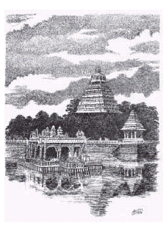
This is a huge temple tank about 5 kms east of the Meenakshi Temple. The mandapam in the centre has an idol of Vigneshwara (Vinayaka). This tank was said to have been dug by Tirumala Nayaka. It is the biggest tank of its kind in Tamil Nadu and one of the most imposing sights of Madurai when it is full of water. The Vinayaka idol was found when the earth was being dug out from here to build the Thirumalai Nayakkar Mahal. So, the place attained sanctity and was converted into a teppakulam (tank). This enormous temple tank is fed by water brought from the Vagai through an ingenious system of underground Channels.
King Thirumalai Nayak was born under the 'Poosa' Star Hence, in commemorating the birth of the king, Float Festival (Teppam) is held in this tank, in the Tamil Month 'Thai' (Jan/Feb). This festival is very colourful, and attracts thousands of tourists.

Azhagar Koil
This is a Vishnu temple located 21 kms north of Madurai on a picturesque wooded hill. Here, Vishnu presides as Meenakshi’s brother “Azhagar”. During the Chithirai festival in April/May,
when the marriage of Meenakshi to Sundereshwarar is celebrated, Azhagar travels to Madurai for the wedding ritual.

Palamudhirsolai, one of the six abodes of Lord Subramanya is on the same hill, about 4 kms. above. A natural spring called Nuburagangai where pilgrims bath, is located here here

Thiruparankundram
Thirupparankundram, 6 kms southwest of Madurai, is a small town known for its sacred granite hill. It is regarded as one of the six abodes of Lord Subramaniya.
It is a cave temple . Here Lord Muruga was wedded to Devayanai, daughter of Indra, after annihilating Surapadman.
There is a Rock cut temple here, built by the Pandyas in the 8th century. The temple is approached through a series of 17th and 18th century mandapas, at ascending levels, linked by stone steps.
In the temple there are separate shrines dedicated to Shiva, Ganapathy, Durga, Vishnu and other deities.
At the entrance to the temple there are 48 pillars with artistic carvings. The mandapa at the entrance has typical Nayaka period pillars with horse and yalli riders, while portraits of Nayaka rulers are carved on the columns. The Rock-cut Temple of Subramaniya here is thronged with pilgrims on all days of special worship. Its innermost shrine is cut out of a solid rock.
The 14-day temple festival, in March/April, celebrates the victory of Murugan over the demon Suran, his coronation, and his subsequent marriage to Devayani.Located 8 kms south of Madurai Junction, the temple here is one of the six abodes of Lord Subramanya. Its innermost shrine is cut out of solid rock.
Athisayam Theme Park
Located at a distance of 12 kms from Madurai (Dindigul road, Paravai). Athisayam theme park, the only one of its kind in this part of the region, promises you non-stop fun. Worldclass water sports offer plenty of exciting entertainment.

Around Madurai

Vaigai Dam
This is a popular picnic spot 70 kms from Madurai. Well laid out
gardens on one side of dam is a prime attraction. On Sundays the dam is illuminated with an array of coloured lights.

Kanyakumari
It is known as “The Land’s End” of India, where the Bay of Bengal meets the Indian Ocean and the Arabian Sea. This is a good place to watch the sunrise, sunset and the moonrise over the ocean. It also has a temple, a striking memorial to Gandhi and a good museum on Swami Vivekananda’s life. You could either travel by train or by hiring a taxi.

Coimbatore
Coimbatore is between 41/2 to 6 hours travel by train from Madurai. It has a very big ‘Landmark’ bookstore with a vast collection of children and adult books as well as Indian Print Stationery.

Kodaikanal
Kodai is an enchanting hill station 2130m above sea level on the Western Ghats and 120kms from Madurai. Travel time is 3-4 hours. For trekking, Kodaikanal is an ideal place.
Ooty
A hill station bigger than Kodaikanal with an influx of new, modern development surrounding it, the old Ooty still manages to retain its charm and appeal. At an elevation of 2333 meters, Ooty makes for a great escape from the heat of the plains below. Hiking, horseback
riding and rowing are the main attractions. There is also a beautiful botanical garden on the edge of the town, and peaceful St. Stephen’s Church that has views out over the town. The best way to get to Ooty is on the toy train (Blue Mountain Express) from Mettupalayam, which is 40 minutes from Coimbatore.

Thekkadi (Kerala)
Periyar Wildlife Sanctuary is 155kms from Madurai. Situated in Kerala, the forest of this beautiful sanctuary slopes down to a manmade lake. From onboard motor launches one can view
wildlife in their natural habitat. Elephant, gaur, sambhar, bear, even tigers and leopards come down to drink the water of the lake.

Cochin (Kerala)
The fascinating city of Cochin has a plethora of things to see including churches, winding streets crammed with 500 year old Portuguese homes, Chinese fishing nets, a Jewish community
whose roots go back to the diaspora, a 16th century synagogue and a palace built by the Portuguese. The best way to get there is by hiring a taxi, which may cost you around Rs.3000 (US$70).

Backwaters Trip ((Kerala)
Kerala is a labyrinth of lazily meandering backwaters. Sprinkled with traditional houseboats, country crafts, rural lifestyles and tranquility. It’s an intricate network of innumerable lagoons, lakes,
canals, estuaries and the deltas of forty-four rivers that drain into the Arabian Sea. Kerala lives along these backwaters. They snake over the state physique, bestowing paddy fields with good harvests, and provide the whole village with drinking water and other facilities. The backwaters refer to the large inland lakes of Kerala. Today these backwaters act as vital water ways for the transport of people and produce.
There are tourist cruises available from Allepey or Kollom running daily and you can choose to go one way only or return to where you started. A more expensive option is to hire a houseboat, but it is definitely worth the cost.
Ayurvedic Resort (Kerala)
A real treat for your body and mind is a trip to the Ayurvedic resort – An Indian style health place. Ayurveda (meaning life knowledge) is the traditional health science of India. At the resort you can
have a variety of treatments including a general massage, various hot oil treatments, a medicated steam bath and a facial. There are also 7 to 28-day treatment packages designed for different illnesses or for general health care. Yoga classes are also held. One such
resort is the somatheeram Ayurvedic Beach Resort located south of Kovalam. Set upon the hill overlooking a wide beach and the Arabian Sea are traditional style Kerala housing with Western
amenities. A private beach and excellent restaurant with superb service are also available.

Megamalai
130 kms from Madurai, Megamalai lies 1500 m above sea level. One has to climb up from the Chinnamanur side. There are many cardomon estates and tea plantations in the hills. Wild animals like sambhar, elephant, tiger, cheetah, gaur and spotted deer are found
amidst thick vegetation.

Coutrallam
Coutrallam the spa of the south is situated at an elevation of about 167 mon the Western Ghats in TirunelveliKattabomman District, 160 kms fromMadurai. It has nine waterfalls. The
water as it gushes through different herbs of the mountain absorbs their medicinal properties. A shower in the falls makes one’s body and spirit hale and healthy.

Rameswaram
Known as the ‘Varanasi of the South’, Rameswaram is a major pilgrim site for Hindus. With temples, shrines, and an incredible beach, it makes for a nice day or an overnight trip from Madurai. Bus tours leave at 7.00 am and return in the evening at 7.00 pm. Hiring a car and driver is also a good option. It takes four hours to get there and the drive itself is picturesque.

.

