Creating The Button
Create a graphic which will be the top level of your menu, and make it a button and call it MenuButton. Create the Over and Hit frames - it makes for a more interesting menu. You don't need to add a down state because we won't be clicking it.
Next, create another button which we will use for the items in the submenu. Don't add text to this. Call it SubButton. Also add the Over, Down and Hit frames.
Now we come to the fun part. Create a submovie (F8, movie) containing your MenuButton. Call it PopMenu. Make sure this is centered to the page (use the Align tool).
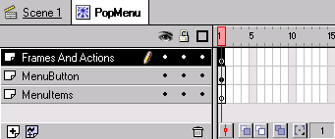
Editing PopMenu, create two more layers and name them in this order: Frames and Actions, MenuButton (this one is the original layer), MenuItems
Now down the timeline (say about frame 20) create some keyframes by pressing F6. Make sure there is a keyframe (blank or used) in each layer.
At Frame 1 on Frames and Actions double click it and label it Hidden. Also add an action to this frame to Stop (click the + button, then choose Stop).

Displaying The Menu
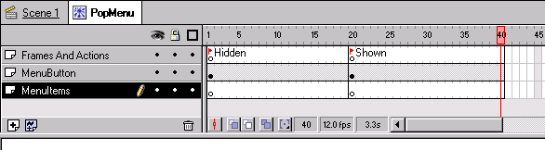
Now at the second lot of keyframes add the label Shown. Add some more blank frames after Shown so you can see the Label. It should now look like above.
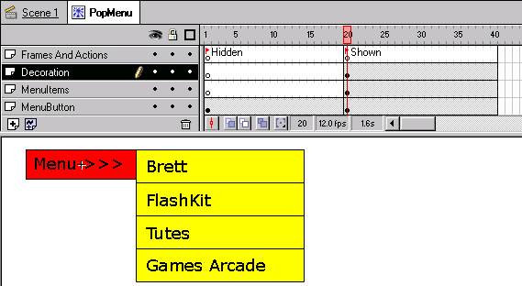
On Menu Items, at the Shown section, position copies of your Sub Button how you want them to be displayed. Add the text you want to the buttons on a new layer called Decoration on a keyframe at Shown.
Button Tracking
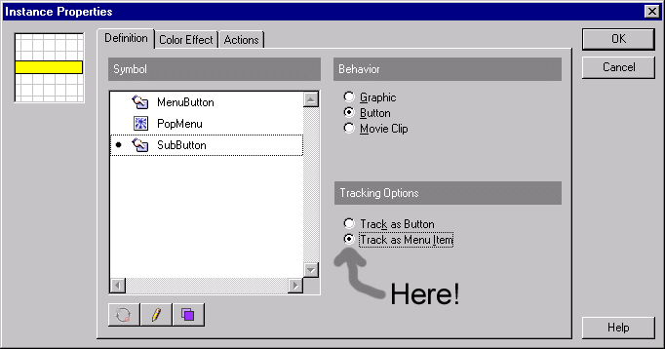
Now make each of your buttons tracked as a menu item by opening each button instance's properties and selecting "Track as menu item" on the Definition Tab.
OK, now you've got it looking how you want it to, and have created the two stages to the menu. Good Stuff! I'm sorry to say it could get kinda tricky now.
Actionscript
Return to the Hidden frame and doubleclick the MenuButton. (Make sure Control, Enable Buttons isn't checked). Now add the action below. It will goto the shown frame when the mouse is rolled over the button.
On (RollOver) {
GotoandStop ("Shown");
}
If you want, you can press Ctrl-Enter to test your new menu. But there's one problem. The menu doesn't go away again. So go back to the PopMenu editing screen.
Add a new layer below all the other layers and call it Hider. Create a blank keyframe on this layer at Shown. Make a rectangle that is larger than the entire menu system at this frame. Include a decent amount of extra space around the menus, as this will trigger our menu back to the Hidden frame.
Closing Thoughts
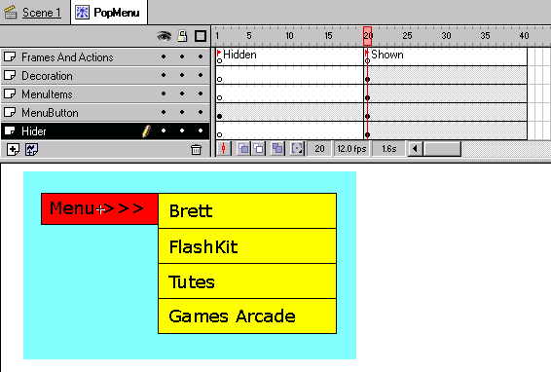
Make this rectangle into a button object (F8, button). Call it MenuHider. Edit the button so it only has a Hit frame and no other frames. This will make the button invisible, yet still clickable, which is what we want.
Open the properties for the invisible button and add this action:
On (RollOver) {
GotoandStop ("Hidden");
}
WELL! The menu has been made! Test it again, and see how it hides itself! YOU DID EXCELLENTLY! You can now add actions to the menu buttons, and experiment with different layouts such as an animated one. Also, try putting menus in menus to get a sub-sub-menu and so on...
If you need a hand with this tutorial, feel free to email me or you could post a question in the Forum.

DRAGGABLE MASK:
First rename layer one of the main stage to be called “navigation” create a new movie clip called “navigation” give it the instance name of “navigation” as well or something similar. Rename layer one of this movie clip to be called “background”.
Create two pictures (I find that two pictures the same but one in black & white the other in colour works best but experiment to see what works best for you.)
On the layer called “background” place a new movie clip called “background picture”, import the black & white picture to layer one of this movie clip. This is the picture that the user will see when the mask is not passing over it. You can now lock this layer for now.
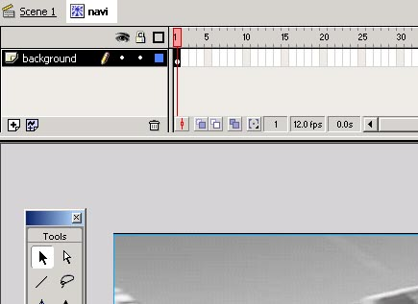

Add two more layers to the background movie clip one called “mask” and one called “masked”. In the layer called masked create a movie clip called “masked background” containing the colour picture of the background. In my example this is the colour picture of the taxi. Make sure that this layer is aligned exactly with the black and white version of the picture using the align buttons. Lock this layer as well so that you don’t move the picture.
You should now have the two pictures on the stage: the colour one sitting on top of the black and white version. Now it is time to create a shape that will be “dragged” across the two pictures: the mask.
On the layer named “mask” create the shape, in the example I have used a horizontal rectangle. Bear in mind at this point how many buttons you want on the navigation bar. Make the mask the same size or slightly larger than the buttons so that when you mouse over them the mask fits snugly. Make the mask into a movie clip and call it “mask”.

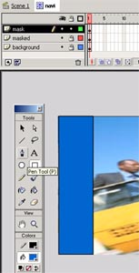

Now right click the layer called “mask” and mask the layer called “masked”. Preview the movie just to check that it is working properly. If it is you should see the colour picture showing through the mask.
You are about to add the masking movement to the movie clip so unlock all of the layers and do the following calculation:
Take the width of the movie clip picture and divide it by four. This will give you the number of frames to add to the timeline.
In my example the picture is 550 pixels wide so the calculation is 550 / 4 = 137.5. Round this number down to the nearest integer. In my example this will be 137. Now place keyframes at the corresponding number on the timeline. Then select the layer called “mask” and move the mask movie clip to it’s final position at keyframe 137. In my example the mask scrolls from left to right so I moved it to the far right of the movie. Then select frame number 1 and right click it. Select “Create Motion Tween” to make the mask scroll across. If you preview the movie you should see the mask move across the stage revealing the colour picture as it goes across.
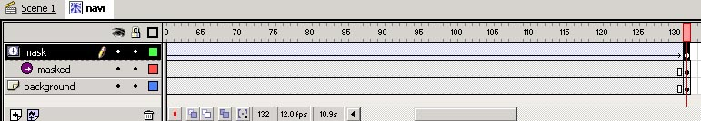
This is the layer where we will add the actionscript to make the mask drag work. The first thing to do is to add a new layer called “actionscript”, lock all of the other layers so that you don’t move any of the elements by mistake. On the “actionscript” layer create a new movie and call it “actionscript”, edit this movie clip. On the first frame place a keyframe and then place one on the 2nd frame aswell.
Place the following code into both keyframes:
x_mouse = _root._xmouse;
y_mouse = _root._ymouse;
if ((x_mouse>= 0) and (x_mouse <=545)) {
_root.navigation.gotoandstop(Math.round (x_mouse/4));
}
What this does is it sets two variables one to be equal to “_root.xmouse” which is the x co-ordinates of the current cursor and one to be able to the y co-ordinates. Then the “If” statement tells the navigation movie to check if the mouse cursor is within the boundaries of the picture. I have removed 5 pixels from the maximum value to stop the navigation movie trying to go to keyframe 138 where there is nothing to show. If the “x_mouse” value is within these limits then the “navigation” is told to goto and stop at the value of the “x_mouse” variable (rounded to the nearest integer “Math.round()” ) and divided by four) You have to divide by four to keep the number of keyframes required for the movie to a manageable number. The same code is put into both keyframes to make the movie run smoother . And that’s all the actionscripting you will need!

Now return to the “navigation” movie timeline, drag an instance of the “actionscript” movie clip you just created to the “actionscript” layer. Now if you preview the movie it will drag the mask across the two pictures and reveal the colour one “through” the black and white one. Make sure that the “actionscript” layer has frames inserted all the way to the final frame of the “navigation” movie otherwise it won’t work. Finally add a “stop” action to the first frame of the actionscript layer to stop the “navigation” movie from playing when first loaded.
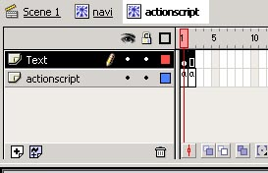

It is now simply a case of adding however many buttons to the navigation movie that you need. Create a shape (As I mentioned before it is best to make it fit within the mask) and make it into a button symbol. Add a layer to the “navigation” movie clip called “buttons”. Place as many instances of the button as you require on this layer. Right click the button and add a keyframe to the “hit” keyframe. Now go back and delete the content of the “Up”, “Over” & “Down” keyframes. This will create an invisible button that will activate when you hit the shape that you have put there.

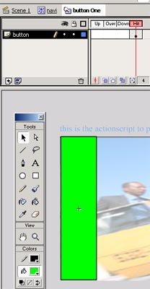
These buttons can then be assigned any actions that you want.
That’s it happy flashing!

CUSTOM CURSOR

onClipEvent (mouseMove) {
i++;
this.duplicateMovieClip("star"+i, i+10);
_root["star"+i]._x = _root._xmouse;
_root["star"+i]._y = _root._ymouse;
}
onClipEvent (enterFrame) {
if (this._name == "starParent") {
_visible=0;
}else{
this._alpha -= 5;
this._rotation += 2;
this._xscale -= 5;
this._yscale -= 5;
if (this._alpha <= 5) {
removeMovieClip(this);
}
}
}
if you are a rookie in flash you will be a bit confused but just try reading it. If you don't want your trail to rotate simply puy "//" in front of the this.rotation. If you haven't met these signs before in flash here are what they mean. ++ means what ever is in front of it plus 1, +=/-= is a quick way of doing "a=a+b" so it becomes "a+=b" and it simply the same with -=.

Last notes
If you notice in the coding in the first if statement you see starParent because that was the instance name I chose for my movieclip.So if you give yours a different name make sure you change the coding.

