MS EXCEL

What is a Spreadsheet?
A Spreadsheet is a grid of rows and columns also called as a worksheet.

Spreadsheet programs and their applications
Spreadsheet programs are developed to automate tasks such as technical calculations, inferential statistics, analyzing data. They also have a powerful program for graphical preparation of numerical data.
- Production planning
- Personnel Management
- Marketing
- Payroll
- Accounting
- Depreciation Analysis
- Order processing / Invoicing
- Tax assessment
- Quality control
- Preparation of product reports

Excel Components:

The Spreadsheet component:

It displays and analyses text and numbers in rows and columns

The Database component

It manipulates lists of information

The Chart component:

It produces charts that help to present data in a graphical manner

Excel features:
- Worksheet and graphics:
It includes extremely powerful calculating features. Besides working with numbers and texts, Excel also provides for presenting data graphically. This helps to large extent for data analysis.
- Data lists and Databases:
Database functions are another important feature of Excel. Several effective functions are available for working with data listed in a tabular form. There are functions for evaluating, combining and if necessary rearranging data list.
- Data Exchange with other applications:
Excel uses the advantage of the window environment. This espcially applies to Dynamic Data Exchange and Object linking and Embedding (OLE) within Excel and between Excel and other windows applications.

- Standard user interface:
Excel is a part of the Microsoft’s application package MS-Office, other products being Word and PowerPoint. Except for a specific menu in each application, the menus in the main Menu Bar of Excel, Word, PowerPoint are identical.
- Workbooks:
Finally, Excel works with a consistent file concept. All data is gathered in wrokbooks. These workbooks store current status of the workspace, along with all currently opened files and the settings selected for them.

How to load Excel?

Click on the Excel Icon to run the Excel.

The Opening screen of the Excel would be as given below:

Formatting toolbar
Application Window Minimize &Maximize

Reference Area Formula Bar Buttons
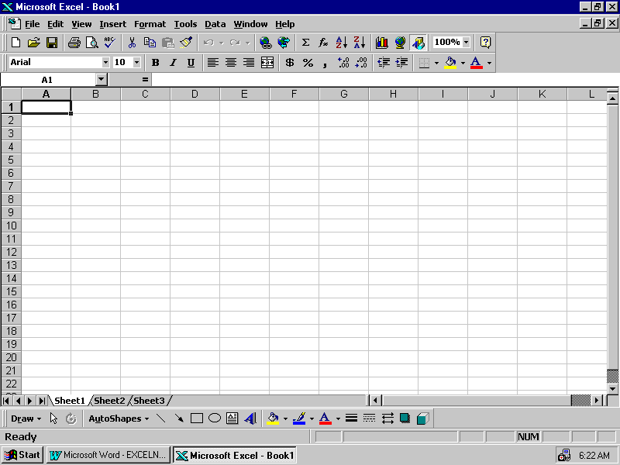
Scroll bars

Sheet Tabs
Excel organizes data in a single worksheet by location. The worksheet is displayed as a grid of 65536 rows and 256 columns. The intersection of a row and a column is called as a Cell. There are approximately 16 million cells in a single worksheet and each cell can hold upto 255 characters or upto 1024 characters in a formula. Light gray lines known as grid lines surround each cell.

Each cell is identified by a Cell Address, which is made up of a row and a column number.

Moving around the Worksheet:
Keys | Function | With Control keys | With ALT Keys
Right | One cell Right | Right on window
Left | One cell Left | Left on window
Up | One cell Up | Top of window
Down | One cell Down | Bottom of window
Pg-UP | One Page up | Next Sheet | A20
Pg-Down | One Page down | Previous sheet | I20
Home | 1st column | To A1
End | * | To H10

*End key with combination of four arrow keys moves to four extreme ends in the worksheet. To use this, press ‘End’ then the arrow key to which the direction you want to go.
Moving with Mouse:
You can also the use the mouse to move around the screen. Move the cursor with the mouse and click the cell to make it active.

Drag the scroll bar to move
Click a tab to display left or right
The sheet Drag the scroll box to move
Up or down
Click arrows to move one by one

Creating a Workbook:

Creating a workbook is a primary function in Excel and it is the first thing every user needs to know. Each worksheet in a workbook can contain text, numbers, dates, formula etc. All information that the user types on a sheet is stored in cells. Each cell can hold upto 255 characters.

When Excel recognizes that text is being typed, it automatically left-aligns the text in the cell. When numbers are typed, Excel right-aligns them.

Entering Text:

Position the Cell and type exactly how do you want. If you want it to print in capital letters, do type so.

Entering beyond the column width limit will be printed in the next columns.

Entering Numbers:

Excel allows numerical data with commas, dollar sings, percent signs and scientific notation.

Numbers can include:

0 to 9
+ - () , / $ % . E e

To enter numerical data, position the cursor, type the data and press enter to store it.

Entering Fractions:

Fractions (2/3, 4/3) can also form a part of the spreadsheet. To enter the fraction,
The whole number and the fraction should be seperated by a space.

For eg. 5 4/5

If the fraction does not have the whole part:-

A zero should be placed in front of the fraction. For eg. 0 2/3

Entering Dates:

Excel treats dates in a special and different way by establishing a date serial scheme. This scheme allocates one number for every day from January 1,900 (date serial number 65380) to December 31,2078 (date serial number 65380). Make the cell E5 active and type the dates under the heading Date of joining in the format dd/mm/yy

Entering Time:

As in the case of date, Excel has a scheme for calculating time.

- is midnight
0.50 is noon and 0.999988 is 11:59:59 PM

Date and time can be type in a same cell separated by a space
Type am or pm to display according to 12-hr clock.

Entering data in a series

To fill a cell range with data that forms a series the data input can be automated. This feature is called autofill. This function is useful when you want to enter continuous data like numbers from 1 to 100, Month from jan to dec and etc.

EDITING worksheets:

- Insert Rows /Columns
- Delete Rows /Columns

- Re-arrange Data
- Copy Data
- Copying and Pasting cells for special results

- Move Data
- Delete Data

- Undo the editing
- Spell check feature

Inserting cells:

Place the cursor at which you want to insert the column or row. You can choose the option to shift the data to right or left side to the new column and top or bottom to the new row.

Delete Cells:

You can either delete the contents of cells or entire column or row.

To delete the contents in a cell or group of cells, select cell/cells and press delete key

To delete row/column, select the row/column, Choose Edit, Delete command then select entire row or column.

Re-arranging data:

Copying Data:

Select a cell or range of cells, choose copy tool and place the cursor to the destination then choose paste tool.

Copying and Pasting cells for special results:

A cell can contain number, text or any type of data and also formulas. When you want to copy data from one place to another place, you can select this option to copy formula only or value only or all. If you just use the paste function to paste the formula data, the destination cell will have different results with the current cell information.

Moving cell contents:

Select a cell or range of cells, choose cut tool and place the cursor to the destination then choose paste.

Undo Editing:

It helps to remove the last action and restore to the way it was before it was done.

Spell Check:

This feature is available to correct the spelling errors. Even though you will use more numbers and other types of data than text, this option is available to check the spelling.
Saving a workbook:

Information can be stored/saved for later use.

The worksheet can be saved by using File,Save command Or from the tool bar.

You can also save the worksheet in different format like lotus/amipro etc.

Retrieving / Opening an Existing workbook:

A worksheet can be opened by using File / Open command or from the toolbar.

Protecting a workbook

A workbook can be protected with the password to save from mishandling by other users. Restriction can be made to open as well as to edit.

To protect a workbook with the password, choose option from the file/save menu and give the details.

The password can also be removed at any time by following the same procedure and press Del key in the password place.

Exiting Excel:

After completing the work, you can exit from the Excel. Before you exit, save the active workbook. Do file/close and exit excel. Even if you directly select exit, it will ask to save the workbook if you have made some changes in the active workbook.

Building Formulae and Functions:

Formulae in Excel:

Text formula

Numeric formula

Logical formula

Operator types:

Arithmatic
+ | Addition
- | Substraction
/ | Division
* | Multiplication
% | Percent
^ | Exponentiation

Text Operator (&) to combine cells

Comparison Operators

= | Equal
> | Greater than
< | Less than
>= | Greater than or equal to
<= | Less than or equal to
<> | Not equal to

Entering Formulae:

= c10+c11 Numeric formulae
=c10&c11 Text formulae
=c10<>c11 Logical formulae

Copying/Moving formulae:

Similar to cell contents, formulae can also be copied/moved from one location to another location of the worksheet.

Recalculating formulae:

Excel, usually recalculates any formula that is affected by new entries or changes in values. You can also do it manually with F9 key.

REFERENCES:

References identify cells or groups of cells on a worksheet and are similar to cell addresses. A reference identifies one or more cells for use in a formula or in an instruction:

Reference Operators:

- Single Cell G6
- Range G6:H6
- Union G6,H6
- Intersection G6:H6 G9:H9
Addressing:

A cell can have its own value or reference value of some other cell or group of cells or calculation value of a cell/cells. There are three types of addressing;

- Relative addressing:

The ability to answer a formula from one location to another is called as “Relative Addressing”.

The formulae C12=C10+C11 becomes D10+D11 when you copy formulae from C12 to D12

- Absolute addressing:

An absolute address always points to exactly one address. To give an absolute address you should use $ sign.

Eg. C12=$C$10 , this formulae will not change its value when you copy to some other cells. If you copy this formula to D12 the result will be D12= $C$10.

- Mixed addressing.

It is a combination of Relative and Absolute addressing method.

Eg. $C3 – As per this formulae, Column ‘C’ is fixed, Row 3 varies.
C$3 – Column C varies and Row 3 is fixed.

To view the formulae, Press CTRL+` (back quote) or Select Tools/Options/View Tab and Formulae.

Referring to Other worksheets:

=Sheet2!A1 , the cell content is the value of A1 cell of worksheet 2.

= SUM(Sheet2:Sheet6!$A$2:$C$5), this formulae adds the value contained in the rage $A$2:$C$5 in each of the sheets between and including Sheet2 and Sheet6 and displays the result in the active cell.

Using Names in references:

A name is an easy-to-remember identifier the user can create to refer to a cell, a group of cells, a value or a formula. Whenever you want to use a cell or group of cells for functions, you can define the name for the range of cells and use that name to process.

To define a range name, select the cell/cells and Insert menu, Name, Define and give the name.

Using Autosum:

Autosum function can be used to sum a cell or group of cells. Click on icon to do autosum.

Functions:

Mathematical | Description | Example
Abs(number) | Absolute value of a number | -25 | 25
Ceiling (number,significance) | Number rounded to the nearest integer | 25.272 | 25.5
Exp(number) | E raised to the power of a given number | 5 | 148.4132
Int(number) | Number rounded to the nearest integer | 25.9 | 25
Fact(number) | Factorial of a number | 3 | 6
Mod(number ,divisor) | Remainder of anumber from divison | 23 | 1
Round(number,no.of digits) | Rounded to the nearest specified integer | 23.871 | 23.87
Sum(num,num2 …) | Total of arguments |  | 254.7832
Log(number,base) | Logarithm of a number to a specified case | 10 | 1
Statistical Functions: | Description | Example
Average(n1,n2…) | Average of arguments | 14 | 56.72959
Count(vi,v2) | Counts no. of arguments in the argument | 6 | 9
Max(n1,n2) | Maximum value in a data set | 523 | 254.7832
Min(n1,n2) | Minimum value in a data set
Financial Functions:
FV(rate,nper,pmt,pv,type)
Returns the future value of an investment based on periodic, constant payments and a constant interest rate.
Rate is the interest rate per period.
Nper is the total number of payment periods in an annuity.
Pmt is the payment made each period; it cannot change over the life of the annuity. Typically, pmt contains principal and interest but no other fees or taxes.
Pv is the present value, or the lump-sum amount that a series of future payments is worth right now. If pv is omitted, it is assumed to be 0 (zero).
Type is the number 0 or 1 and indicates when payments are due. If type is omitted, it is assumed to be 0.
FV(11%/12, 35, -2000, , 1) equals $82,846.25
Suppose you want to save money for a special project occurring a year from now.
You deposit $1,000 into a savings account that earns 6 percent annual interest compounded
monthly (monthly interest of 6%/12, or 0.5%). You plan to deposit $100 at the beginning of
every month for the next 12 months. How much money will be in the account at the end of 12 months?
FV(0.5%, 12, -100, -1000, 1) equals $2301.40

DB(cost,salvage,life,period,month)
Returns the depreciation of an asset for a specified period using the fixed-declining balance method.
Cost is the initial cost of the asset.
Salvage is the value at the end of the depreciation (sometimes called the salvage value of the asset).
Life is the number of periods over which the asset is being depreciated (sometimes called the useful life of the asset).
Period is the period for which you want to calculate the depreciation. Period must use the same units as life.
Month is the number of months in the first year. If month is omitted, it is assumed to be 12.
Suppose a factory purchases a new machine. The machine costs $1,000,000
and has a lifetime of six years. The salvage value of the machine is $100,000.
The following examples show depreciation over the life of the machine.
The results are rounded to whole numbers.
DB(cost,salvage,life,period,month)
DB(1000000,100000,6,1,7) equals $186,083
DB(1000000,100000,6,2,7) equals $259,639
DB(1000000,100000,6,3,7) equals $176,814
DB(1000000,100000,6,4,7) equals $120,411
DB(1000000,100000,6,5,7) equals $82,000
DB(1000000,100000,6,6,7) equals $55,842
DB(1000000,100000,6,7,7) equals $15,845
FORMULA
DB(1000000,100000,10,1,12)
DB(1000000,100000,5,1,12)
DB(1000000,100000,1,1,12)
DB(1000000,0,1,1,12)
Date Functions:
21-Aug-94 |  | 01-Jan-01
22-Aug-94 |  | 02-Jan-01
23-Sep-94 |  | 03-Jan-01
24-Aug-94 |  | 04-Jan-01
now() | Current Date & Time
Today() | Today’s date

Logical Functions | Example
And(11,12) | True if every argument is true | FALSE
False() | Logical value false | FALSE
If(test,true,false) | Returns a specified value depending on the | PASS
90 | outcome of the test
Not(1) | Returns true if its argument is false | TRUE
OR(11,12) | True if ANY argument is true | FALSE
True() | Logical value true | TRUE
Text Functions | Example
Example | Result
Concatenate(“Santa”,”Barbara”) | SantaBarbara
Exact(“Abra”,”Abba”) | FALSE
Find(“&”,”Tom & Jerry”) | 5
Len(“length”) | 6
Left(“Version”,3) | Ver
Lower(“ASKFJD”) | Askdjd
Mid(“Article No.”,9,3) | No
Replace(“Miller”,2,5,”eggs”) | Meggs
Rept(“=”,13) | ==================
Right(“Article Number 23456”,5) | 23456
Trim (“asdfasdf asdffsd”) | Asdffdasasdfsdaf
Uppe(“sdfkj”) | SDFKJ

FUNTION WIZARD:

Functions can directly be entered in a cell following syntax or they can be built using the Function wizard.

To use the function wizard, Insert Menu, Function and then appropriate function that you want to do.

Formatting and Printing a Workbook:

- Using Autoformat
- Number Format, Percentage format, Adding currency format
- Creating a custom format, Aligning workbook data
- Formatting text with fonts, Adding borders, Patterns and Colors
- Inserting page break

You can do all these things with the help of toolbar or menu driven program. All these commands are similar to WORD program.

Printing a Workbook:

Printing a workbook is also similar to WORD or other MS Office programs but here you have to set the are to print before you print the worksheet, otherwise it will just print out whatever can be printed in a page.
Sharing and Managing Data:

Data list is a one of the Excel components. Excel offers certain data management function that will be useful to perform the data management activities.

Linking Workbooks:

When the data size grow, you used to split the data into more than databases (worksheet or workgroups in Excel). It requires to link more than one worksheet/workbook to perform some calculations.

Workbooks can be linked by using reference command.

Eg. A1 = Sheet2!$C$7

Inserting Worksheets:

You can insert the new worksheets at any point of time to enter new information/data.

Copying sheets:

Copying sheets function is useful to create a backup of the worksheet before you manipulate the data in the worksheet and also when you want to use the same worksheet somewhere else.

Moving Sheets:

It is used when you want to order the worksheets.

Renaming the worksheet:

Excel assigns a default name for worksheets like Sheet1,Sheet2. This can be changed with the new name for easy identification.

Deleting a worksheet:

Unwanted worksheet can be deleted to save space in the memory.

All the above functions can be performed from the sheet tool bar.

Place the cursor on the sheet tool bar and right click. You will get the list of options from which you can choose what you want to do.
Data List:

A list is a collection of related data, which is organized, in a tabular form. Each row of information in a list is called a record.

Creating a data list:

There are two ways to create a data list.

- Usual way of creating the data list
- Using Data form command

Guidelines to create data form;

- There should not be more than one data list on the worksheet
- A blank row should be left between the list and other data
- Column headings should be placed in the first row of the list.
- No blank rows between column heading and list
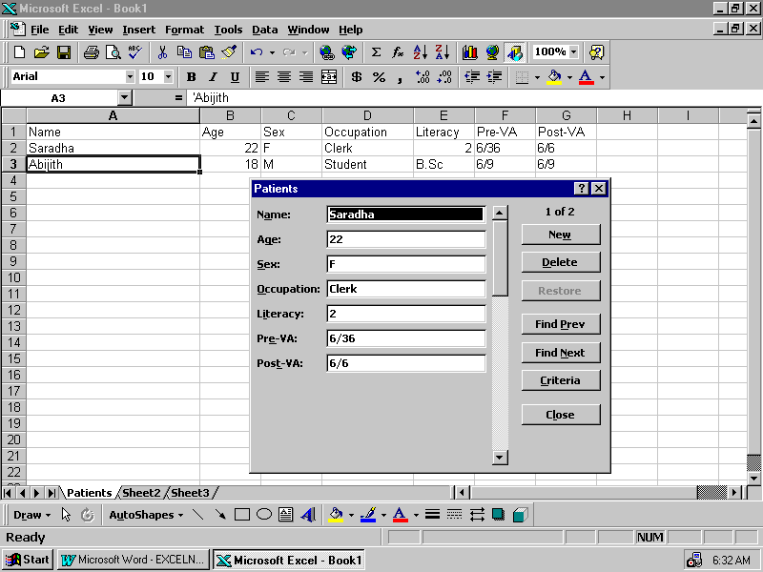

You can Enter a new record, find a record with some criteria, Edit/change the content and also delete the record.

SORTING DATA:

You can perform a simple sort by any column.

FILTERING DATA:

Filtering data is useful to filter the data list with a specific condition and to do some activities. Select Data,Filter to do the activities.
ANALYSING AND ORGANIZING DATA:

Automatic Subtotals:

Excel provides a facility of automatically generating subtotals for data. The data to be subtotaled is divided into groups according to a certain criteria. In order for Excel to identify the grouping, the group must have two or more entries, with the same value, in adjacent columns. Automatic subtotals can be generated by using the Data, Subtotals command.

Step 1: Open the workbook and select the worksheet
Step 2: Sort the data list by a variable with which you want to group
Step 3: Select the Data, Subtotal command from data menu.
Step 4: Select the group variable at Each change in column
Step 5: Select the function you want to apply for grouping (Sum,Average etc.)
Step 6: Select the variables that you want to apply the function

Press Ok to get the results.

Using Pivot Tables:

Pivot tables are tables that let the user ‘turn’ or re-arrange data. The user can interactively exchange rows and columns to look at data in different ways. Excel includes the Pivot table Wizard which works with existing tables.

A pivot table is like a report generator that provides different evaluations of existing data.

To create a pivot table Select the data, Pivot table command. There are 4 steps in this wizard which allows you to do step by step.

Step-1 : Activate the Pivot table wizard
Step-2: Defining range of data
Step-3: Layout the Pivot table
Step-4: Position the Pivot table.

Click Finish to get the result

Charting Data:

Charting is the one of the components of Excel. If data is represented graphically, it becomes more interesting and easy to understand. A Graphical representation also helps in data analysis to a large extend.

A chart is a graphic representation of worksheet data.

Elements of a Chart:

- Y Axis
- X-Axis
- Chart Title
- Category names
- Legend
- Data Marker
- Tick Marks
- Gridlines
- Data labels
- Active border
- Selected border
Chart Title

Grid lines
X-Axis categories
Legend
Y-Axis Values

Types of Chart:

There are lots of options available in Excel and the following are the most commonly used charts.

- Area Chart
- Bar Chart: Column chart,stack bar etc.
- Line Chart: High-low-close chart
- Pie Chart
- Column Chart
- Doughnut chart
- Radar Chart
- Scatter Chart

Creating chart is a simple task in Excel. You can easily follow the chart wizard and through the following process:

Step-1: Select the Chartwizard toolbutton
Step-2: Select the data range to plot
Step-3: Choose the variation of the chart (types and formats of the chart)
Step-4: Choose the Chart orientation and the legend text
Step-5: Title the chart and position the legend

Click Finish to get the result.

Class II: Building Formulae and Functions:

Formulae in Excel
Operator types
Order of Evaluation
Entering formulae
Copying and moving formulae

Addressing Method
Relative
Absolute
Mixed

Using Autosum

References
Reference Operators
Entering references

Using names in references
3-D references
Functions
Entering functions
Function categories
The function wizard

Analysis tools
Goal seek command

Rearranging Cell Contents:

Copying cell contents - Copy & Paste
Moving cell contents - Cut & Paste
Copying and Pasting cells for special results -

Protecting a workbook: File/Save/Options

Formulae in Excel:

Text formula

Numeric formula

Logical formula

Operator types:

Arithmatic
+ | Addition
- | Substraction
/ | Division
* | Multiplication
% | Percent
^ | Exponentiation

Text Operator (&) to coimbine cells

Comparison Operators

= | Equal
> | Greater than
< | Less than
>= | Greater than or equal to
<= | Less than or equal to
<> | Not equal to

Entering Formulae:

= c10+c11

Copying Formulae

Moving Formulae

Recalculating formulae with f9 key

Relative addressing & Absolute addressing

Function Categories:

Mathematical

Statistical

Financial

Date & Time

Logical

Text

Mathematical
Abs(number) | Absolute value of a number
Ceiling (number,significance) | Number rounded to the nearest integer
Exp(number) | E raised to the power of a given number
Int(number) | Number rounded to the nearest integer
Fact(number) | Factorial of a number
Mod(number divisor) | Remainder of a number from division
Round(number,number of digits) | Number rounded to a specified number of digits
Sum(num1,num2, …) | Total of arguments
Log(number,base) | Logarithm of a number to a specified case

Statistical Functions:
Function | Returns
1. Average (n1,n2…) | Average of arguments
2.Count(vi,v2) | Counts how many arguments are present in the list of arguments
3.Max(n1,n2) | Maximum value in a data set
4.Min(n1,n2…) | Minimum value in a data set

Formatting and Printing a Workbook

Formatting a Worksheet
The Format menu
The formatting toolbar
Autoformat

Changing column-widths and row-heights
Copying formats
Printing a workbook
Seeint print range,margins,headers,footers
Charting Data
What is a chart
Chart elements
Chart types
Area, Bar, Column, Line, Pie, Doughnut, Radar,
XY or Scatter charts

Creating a Chart Using
Chart tool on the chart toolbar
The Chart Wizard
Chart option of the Insert Menu

Modifying a chart
Using the chartwizard
Using Special menus
Using Direct edits

Printing a chart

Sharing and Managing data

Linking data
Creating links
Updating links
Removing links
Documenting workbooks
Adding cell notes
Sound notes
Managing workbooks
Inserting sheets
Copying sheets
Moving sheets
Renaming sheet tabs
Deleting sheets
Using a list to organise data
What is a list
Creating a list
Maintaining a list by using data form
Sorting data
Performing a simple sort
Performing a 2-column sort
Filtering data

Filtering data with Autofilter
Using Custom criteria with Autofilter
Advanced Filter

Analysing and Organising data

Analysing data using what-if analysis
Using a one-input data table
Using a two-input data table

Automatic Subtotals – Subtotal Command
Preparing the data
Creating subtotals
Nested subtotals
More than one subtotal in the same column
Removing subtotals
Creating a Pivot table
Steps to creating a simple pivot table
Changing the layout of the pivot table
Working with Page fields
Removing fields
Adding fields
Updating the Pivot Table
Renaming elements
Deleting the table

Automating and Customising Excel

What are macros
Recording macros
Running macros
Documenting macros
Deleting macros
Macro buttons
Attaching a macro to a toolbutton
Restoring the toolbutton
Automatic macros
Customising the workspace
Controlling screen display
Customising toolbars
Zooming in/out
Splitting the worksheet
Arranging windos

